**Report Writing**

**Understanding the Problem Statement: -**

Electricity consumption in Indian homes has tripled since 2000. The percentage of households with access to electricity has increased from 55% in 2001 to more than 80% in 2017. So, to understand the power consumption considering main affecting factors, we have studied the problem.

**Detailed Working: -**

To understand the trend in consumption of power in India, we have analysed consumption based on two factors:

Macro (Socioeconomic)

Micro(Direct use)

1. We have collected electricity consumption data of the Indian states from 2010 to 2021 and examined the usage of maximum power consumption.
2. Maharashtra was at top of the list for consumption of electricity in India. Hence, we focused on this state and analyzed the dependency of electricity consumption on macro and micro economic factors.
3. We have used python programming language to calculate the multiple linear regression and calculated the most important factors on which electricity consumption depends.
4. Then we used correlation test between market penetration for the top ten consuming electrical appliances and significant factors which we got through regression model.

Macroeconomic factors: - Per capita GDP(GDPt), Electricity price(Pt), Unemployment rate(UnEmpt)

Microeconomic factors: - We have considered the top ten high electricity-consuming appliances and analysed the consumption of the electrical appliances popularly utilized in households.

The equation formed using variables described in previous slide for **REGRESSION MODEL** :

**Et =α0 + α1GDPt + α2Pt + α3UnEmpt**​

We have Analysed the data from 2010 to 2021 of the Macro-economic variables, we found these are normally distributed and we could use them for the hypothesis testing.

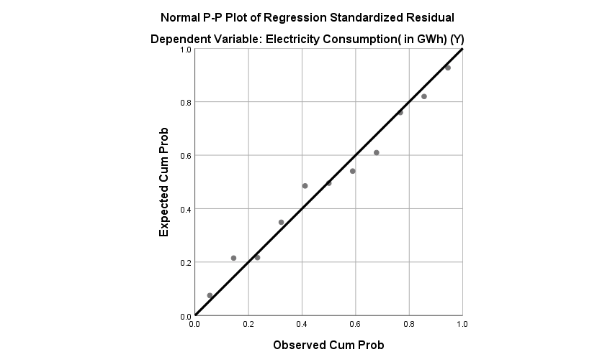

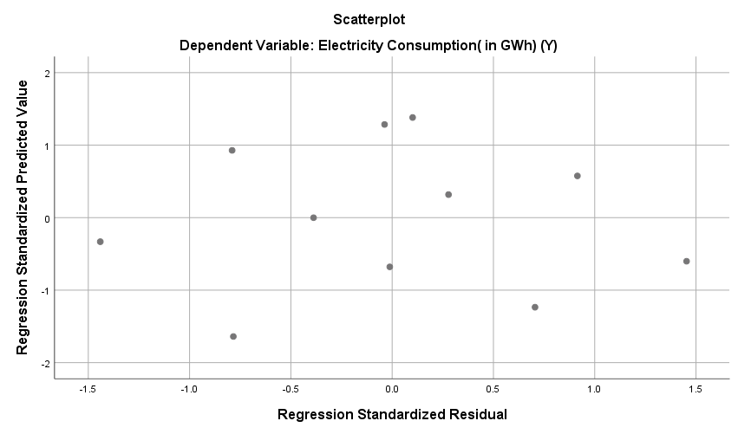

We got the output as follows for the Regression Model: -

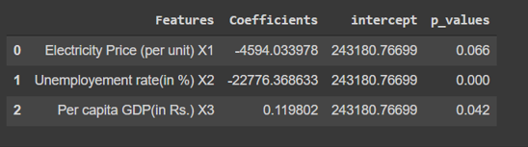

Considering the output of the regression model, we have rejected the Null hypothesis. **P-value of the variables Per capita GDP and Unemployment rate is less than 0.05, so these are significant, so electricity consumption is dependent on them with 95% confidence level.** We can use this model with 90% confidence level considering all these variables and predict the future consumption.

**CORRELATION MODEL**:-

By considering above output of regression model, we are good to consider these two factors for the correlation with top 3 electricity consuming appliances. We have analysed the output of the correlation so that we can concentrate on the factors which are highly impacting electricity consumption.

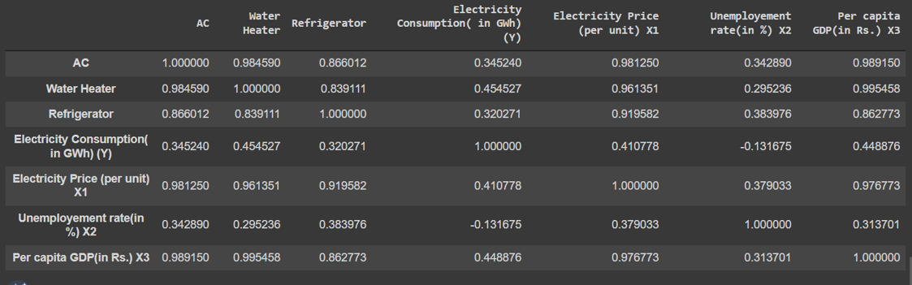

**Solution:-**

We have combined the outputs of correlation and regression model to determine the variables and appliances that should be prioritized. **We have concluded that Per capita GDP and Employment rate highly affects the power consumption. AC, Refrigerators, and Water heaters are the top 3 electricity consuming appliances that should be prioritized.**

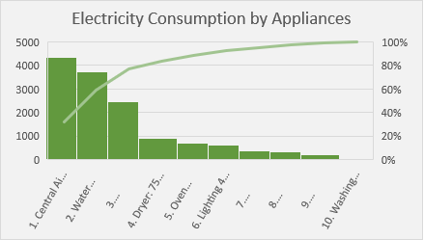

The top 3 appliances that consume the maximum electric power should have a sensor installed in them so that when such appliances are not in use gets automatically switched off to save electricity. The state government should utilize more renewable energy sources to generate power rather than non-renewable sources of energy.Time has indirect relation with the efficiency of the appliances, hence the Govt. should also introduce "Policy of Appliance Disposal" to minimize the consumption of electricity.

**The Way Ahead**

We can reduce the electricity consumption by focusing more on renewable sources of energy like production of electricity through solar, hydro and wind energy.

